*ACKNOWLEDEGMENT*

The first, we would like to express my special thanks of gratitude to my teacher <>, who helped us a lot in finalizing this project within the limited time frame, valuable counselling and assistance for the accomplishment of this project. Secondly, we would also like to thank the eProject team at Aptech Head Office, who gave us the golden opportunity to do this wonderful project about Aura Watch. Thirdly, we also thank the eProject team, some of the benefits are as under:

• Re-enforcement of skills happens in the experiential learning process.

• A mentor, ensuring that we do not get drifted, constantly guides us.

• It gives us a lot of confidence to face an interview as we have worked on a project. We can explain virtually everything on the subject we have learnt.

*SYNOPSIS*

The "Cards Special" website project aims to create a user-friendly platform for a card-making company specializing in birthday, wedding, and business cards. The website will feature intuitive navigation, distinct card categories, and robust personalization options, allowing customers to customize their cards with unique messages, designs, and colors. A secure payment gateway and order tracking system will ensure a smooth purchasing process, while design tools and account management features empower users to create, save, and manage their card designs. With a responsive and mobile-friendly design, social media integration, and SEO optimization, the website will reach a broader audience, fostering brand visibility and organic growth. Through this project, "Cards Special" seeks to solidify its position as a leading destination for heartfelt and customized cards for all occasions.

*PROBLEM DEFINITION*

Red Cards Limited is into selling cards for various occasions. They have a huge

collection of cards. They want to get on to internet with their collection, so that they

can reach various organizations and individuals. They want to host a website with all

the information about their organization and their collection of cards with the

snippets.

**Requirement Specification:**

The Web site is to be created based on the following requirements.

1) Home Page should contain logo of the site with proper sections and details of

cards available.

2) The site should display a menu which will contain the options for brief

introduction about the various categories and cards available, location of the

shop and any other information if required.

3) The information should be categorized according to the brand names of the

cards like if a User wants to see only “ARCHIES” cards or any other

company’s cards then he/she can click on a Link/button/menu etc and can

see only that Brand cards.

4) Another category option for cards of different occasions, like ‘Birthday’,

‘Anniversary’ etc. should be created and accordingly the cards should be

listed.

5) When a user selects any particular brand, a list of cards for that brand will be

displayed

6) A brief summary about individual cards should be displayed on the Web Page

along with the price.

7) There should be a “Contact Us” page which will have the Address of the Store

which is as follows and the mail address which when clicked will invoke the

local mail client from where they can send an email.

*CUSTOMER REQUIRMENT*

*SPECIFICATION (CRS)*

The customer requires a user-friendly "Cards Special" website with distinct categories for Birthday Cards, Wedding Cards, and Business Cards, featuring an intuitive interface that allows easy browsing and personalization. Customers should be able to customize cards with unique messages, designs, and colors, preview their creations, and have access to design tools for creating custom designs from scratch. The website must provide secure payment options and order tracking, while offering a responsive and mobile-friendly design. Social media integration, account management features, and optimization are also required to enhance brand visibility and facilitate organic growth.

*SCOPE OF THE WORK (IN BRIEF)*

The scope of work for the "Cards Special" website project encompasses designing and developing a user-friendly platform with distinct categories for Birthday Cards, Wedding Cards, and Business Cards. The website will offer robust card customization and personalization features, allowing customers to add unique messages, images, fonts, and colors. It will integrate design tools for creating custom card designs from scratch and provide a secure payment gateway with order tracking. The scope includes implementing a responsive and mobile-friendly design, social media integration, and SEO optimization to enhance brand visibility and organic growth. User account management, comprehensive testing, and training for staff will be provided, along with post-launch maintenance and support, ensuring the smooth operation of the website and solidifying the card-making company's position as a market leader in personalized cards for all occasions.

***AGGREGATED SITEMAP***

**Cloth Bag & Box**

**(coth bag box.html)**

**Wedding Card**

**(wedding.html)**

**Wedding Card**

**(wedding.html)**

**Eid-ul-Fiter**

**(Eid.html)**

**2.INSTA PRINT**

**(insta print)**

**1.JAPAN ART**

**(japan.html)**

**Business Card**

**(Business.html)**

**Birthday Card**

**(Birthday.html)**

**Wedding Card**

**(wedding.html))**

**Contact us**

**(Contact.html)**

**Brands**

**(brand.html)**

**Product Card**

**(producy.html)**

**About us**

**(About.html)**

**Home Page**

**(1.Index.html)**

Card Special

**(1.index.html)**

***WIREFRAMES***

CONTENT

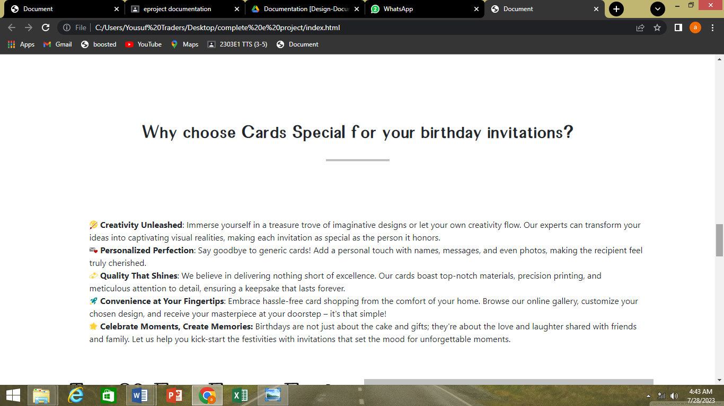

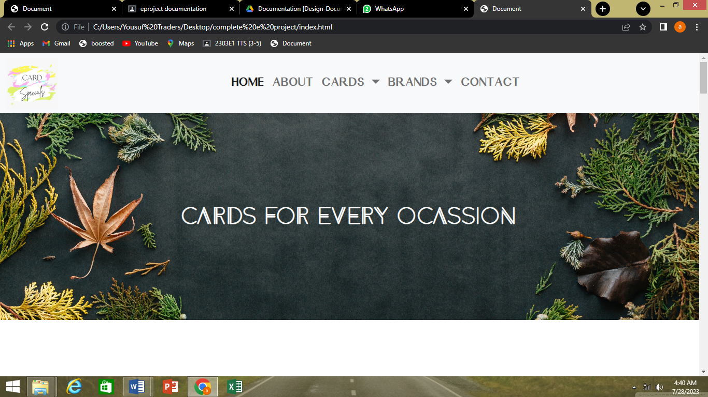

Index.html about.html cards.html brands.html contact us.html

HOME ABOUT CARDS BRANDS CONTACT US

*CARD SPECIAL*

COMPLETE THE DOCUMENT DESIGN

